Exp. No: 4 Measurement and Analysis of Dispersion Compensation in Optical Fiber using OptiSystem

OBJECTIVES
1. To demonstrate dispersion compensation using the Ideal Dispersion Compensation component in OptiSystem.
2. To observe the broadening of a 12.5 ps optical Gaussian pulse after propagation through 10 km of single-mode fiber (SMF).
3. To compensate the accumulated dispersion of 160 ps/nm and verify recovery of the original pulse shape.
SOFTWARE / HARDWARE REQUIRED
• OptiSystem Software
EXPERIMENT PROCEDURE
1.Start a new OptiSystem project.
2. Place a User Defined Bit Sequence Generator and set the global bit rate to 40 Gb/s.
3. Place an Optical Gaussian Pulse Generator (193.1 THz, 1 mW, 12.5 ps initial pulse, 0.5 times bit slot) and connect it to the bit sequence generator.
4. Connect an Optical Time Domain Visualizer and an Optical Spectrum Analyzer at the generator output to observe the initial pulse.
5. Connect the generator output to the SMF and set the fiber length to 10 km.
6. Connect a visualizer and a spectrum analyzer at the SMF output to observe the broadened pulse.
7. Connect the SMF output to the Ideal Dispersion Compensation FBG; in the Main tab set frequency = 193.1 THz, bandwidth = 125 GHz and dispersion = – 160 ps/nm.
8. Connect a visualizer and a spectrum analyzer at the compensator output.
9. Run the simulation.
10. Compare the pulse width before the fiber, after 10 km of SMF and after dispersion compensation.

DISPERSION COMPENSATION BLOCK DIAGRAM
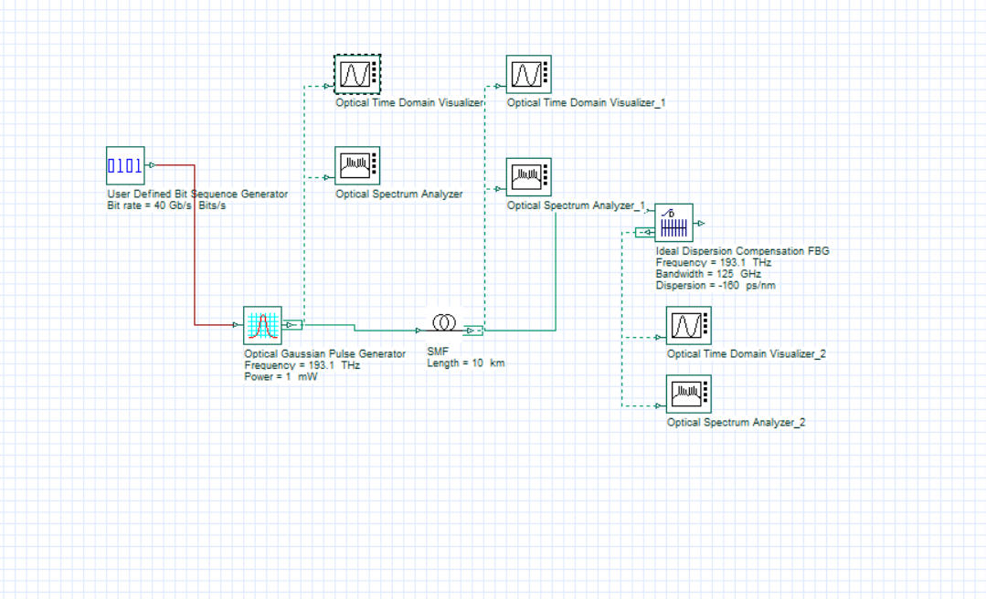

OUTPUT

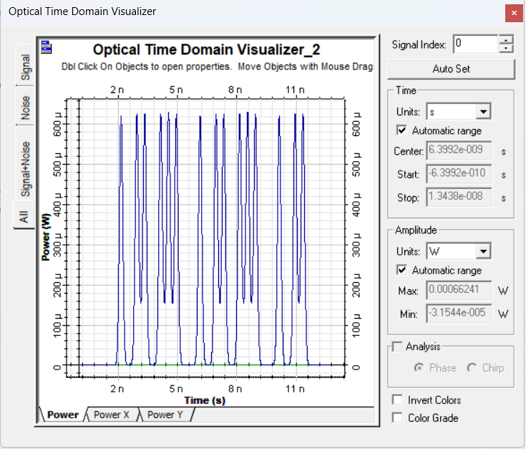

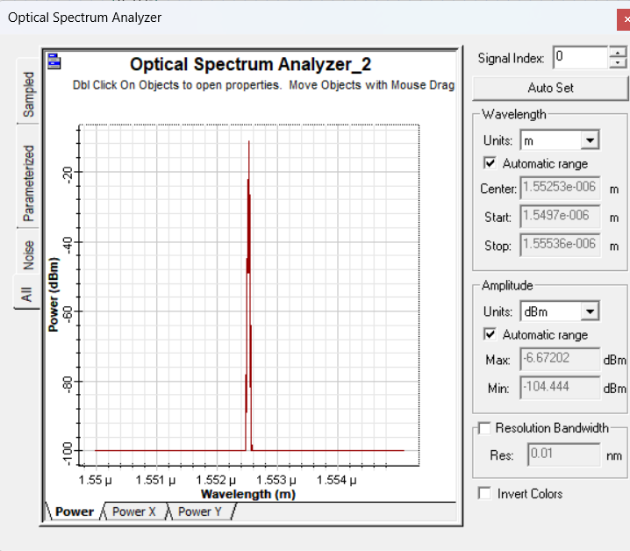
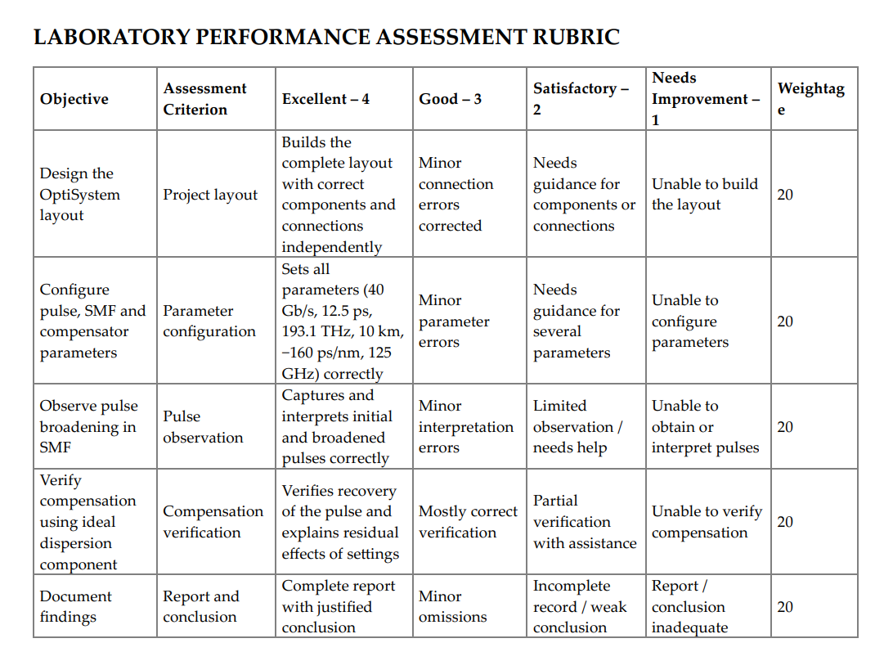
CONCLUSION
Dispersion compensation was successfully demonstrated using the Ideal Dispersion Compensation component in OptiSystem. A 12.5 ps Gaussian pulse broadened approximately four times after 10 km of SMF (accumulated dispersion 160 ps/nm), and sejing the compensator dispersion to –160 ps/nm r

